Collector Node

Use the Collector node to create message collections based on rules that you configure in the node.

Use the Collector node to create a message collection from one or more sources based on configurable criteria. For example, you might need to extract, combine, and transform information from three different sources. The messages from these different sources might arrive at the input terminals at different times and in an unknown order. A collection is defined by configuring an event handler for each input terminal. Each event handler controls the acceptance of a message into a collection according to the following properties:

* Number of messages
* Collect messages for a set period
* Match the contents of a correlation path
* Match the contents against a correlation pattern

1. Click on "File" and select "New" => "Application"

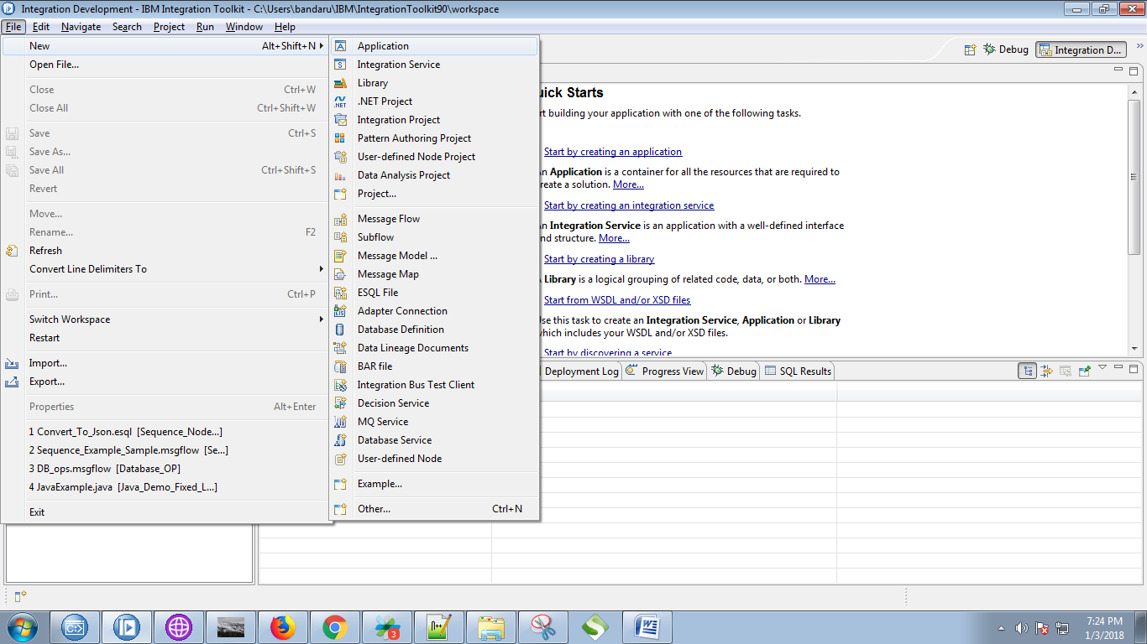

2. Give a name for your application and click on "Finish" button.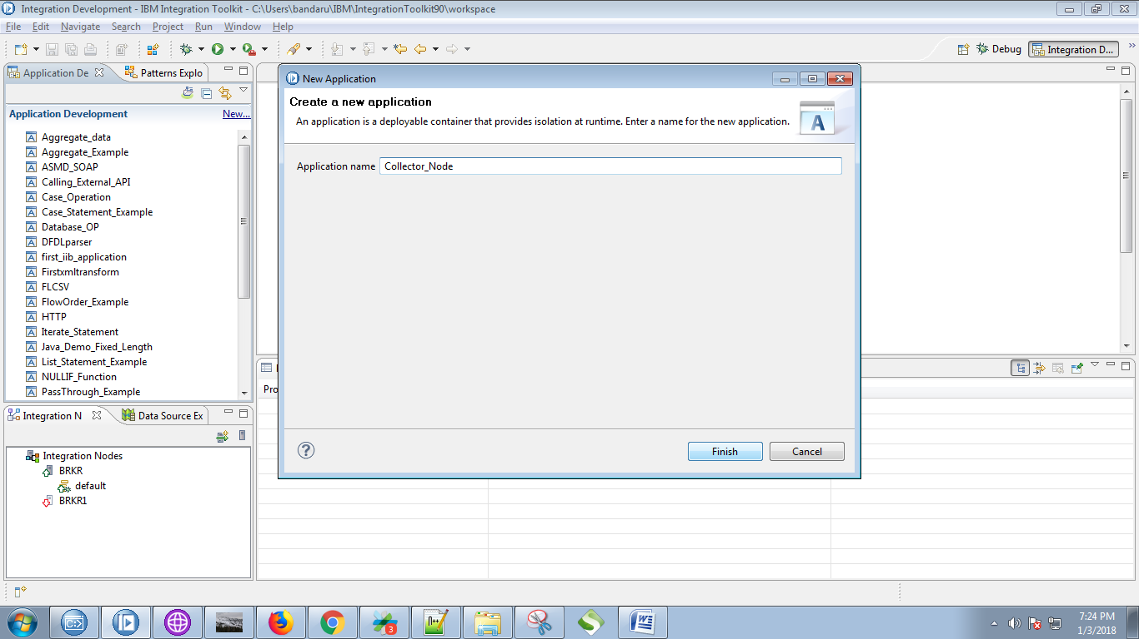

3. Under your application you can see "New" click on it.

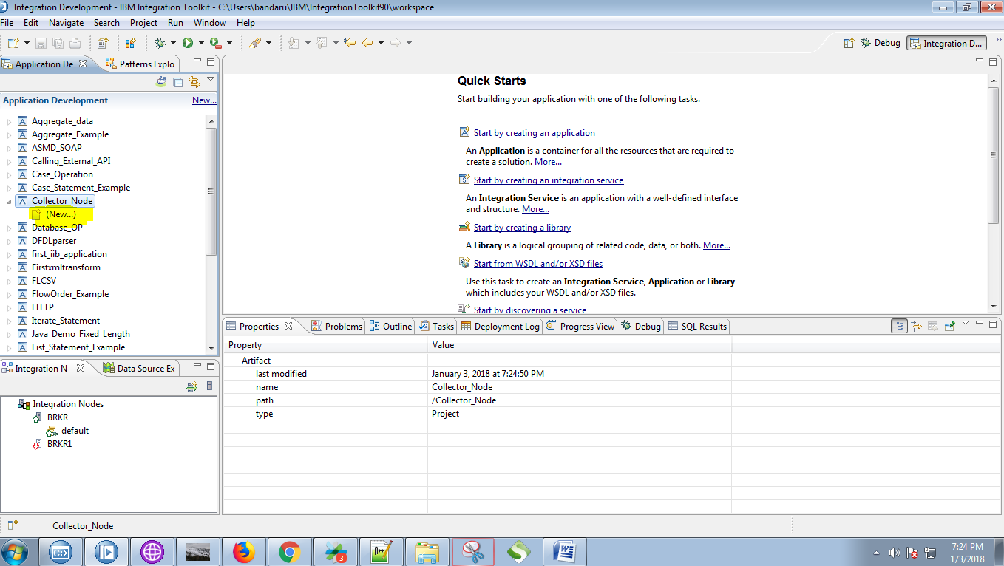

4. Select the "Message Flow" from the given options.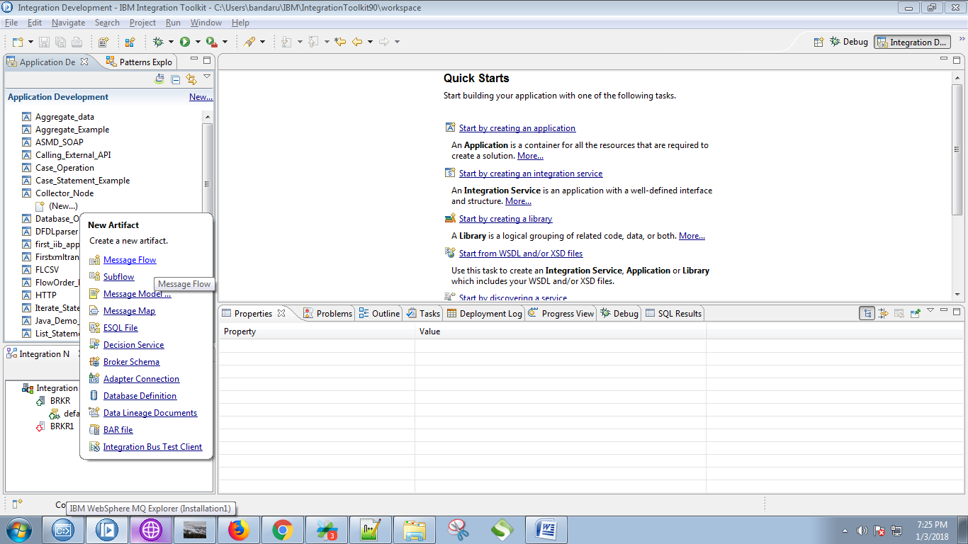

5. Give a name for your flow and click on "Finish" button.

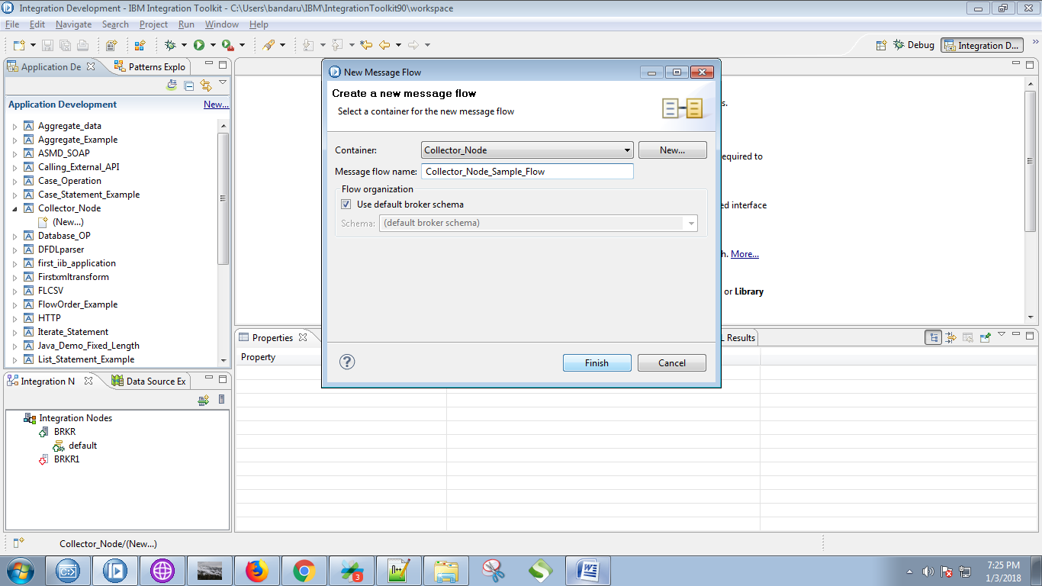

6. Drag the "MQInput" from the "WebSphere MQ" section and give a name for it.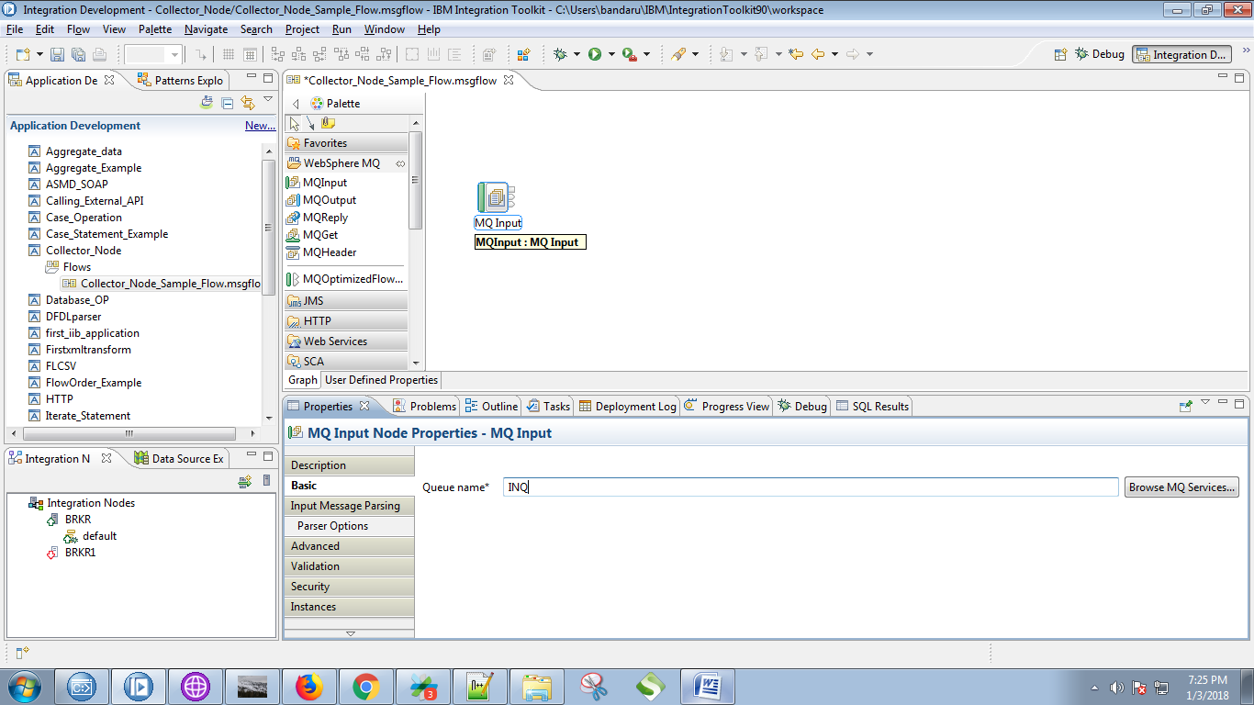

7. Select "XMLNSC" as message domain for MQInput.

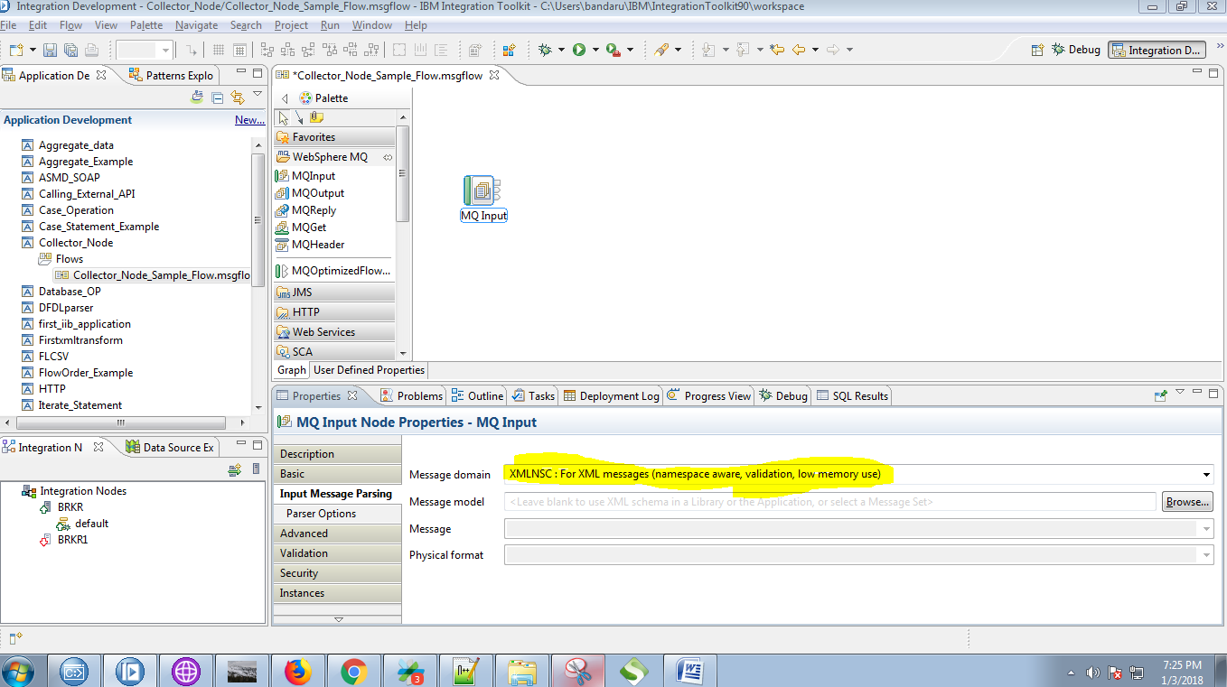

8. Drag the "compute" node from the "Tranformation" section .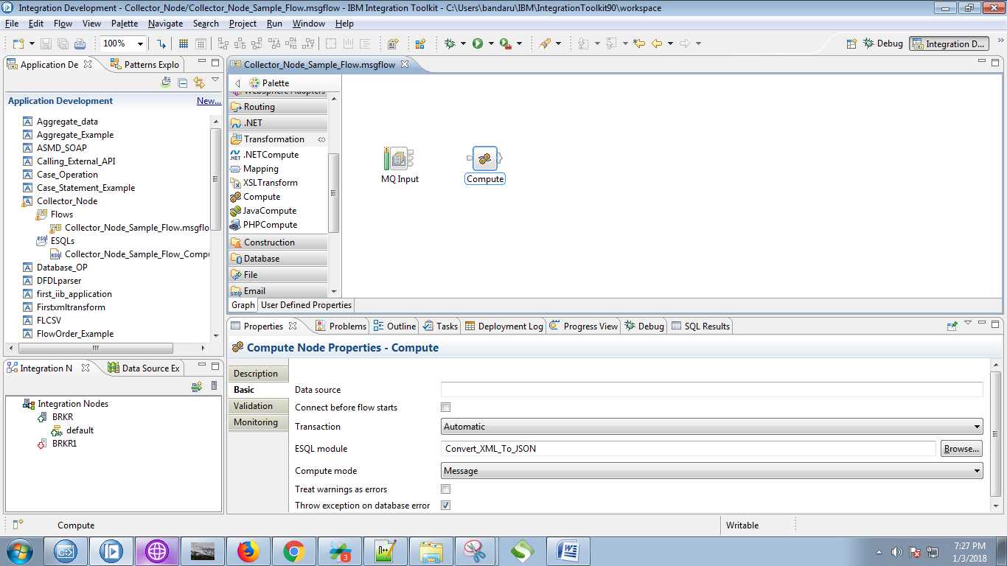

9. Connect the "output" terminal of the MQInput with the "input" terminal of the compute node.

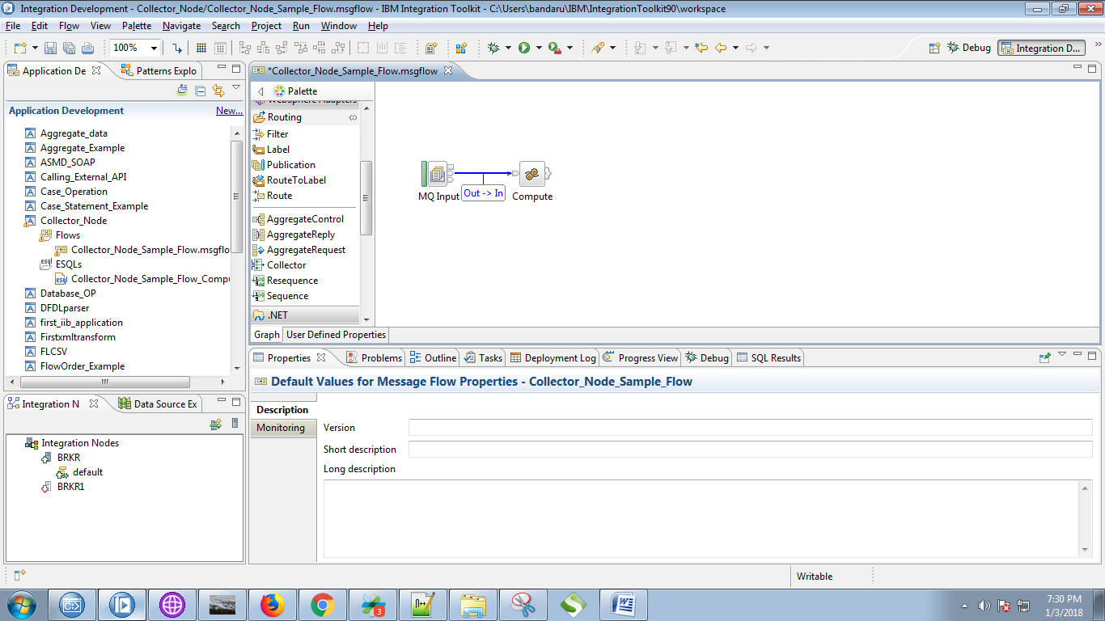

10.Copy the following code in compute node.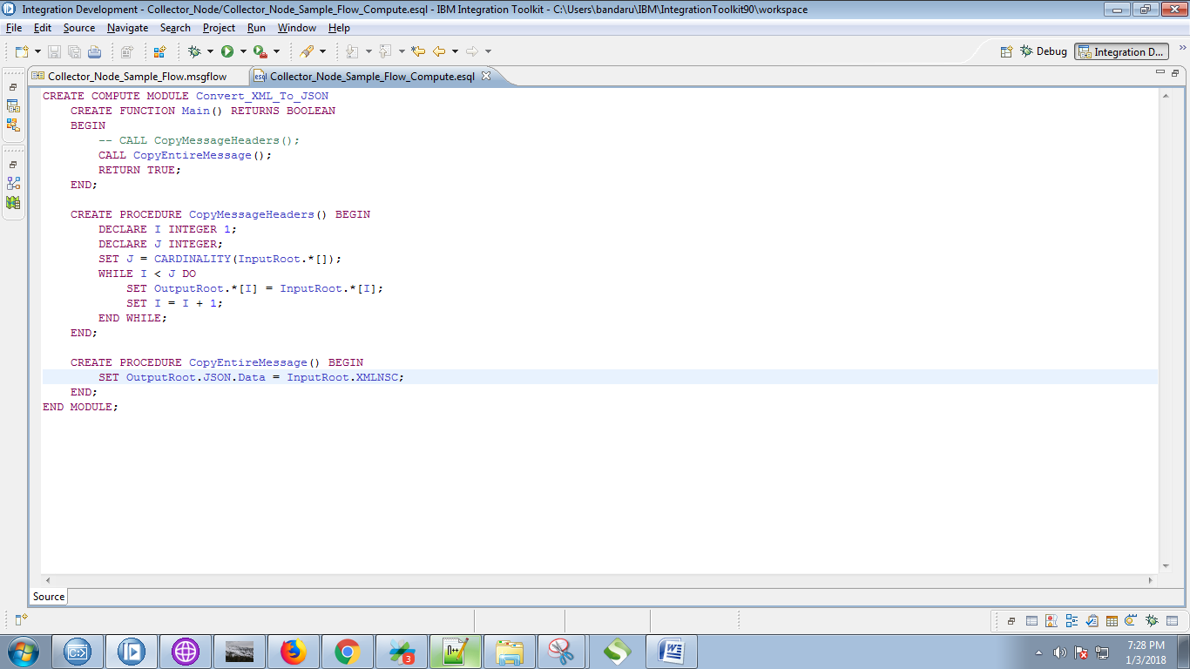

11. Drag the "Collector" node from "Route" section.

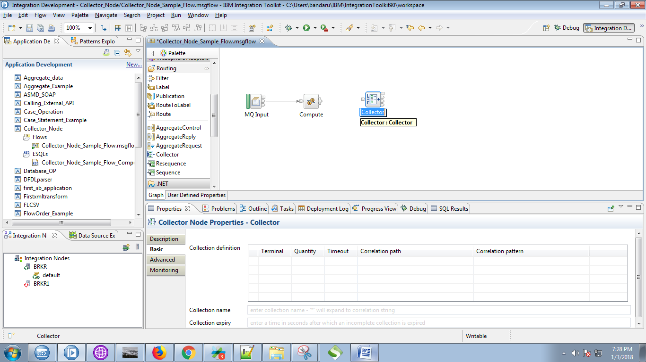

12. Give the following details in "collector" node.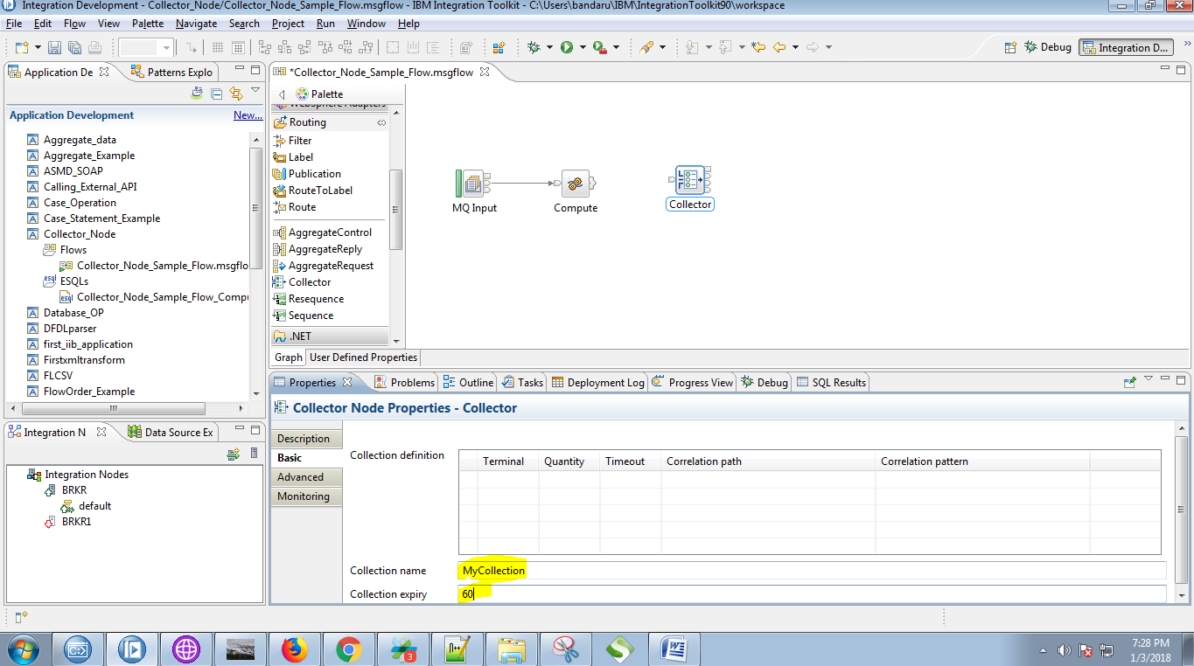

13. Right click on collector node and select "Add Input terminal".

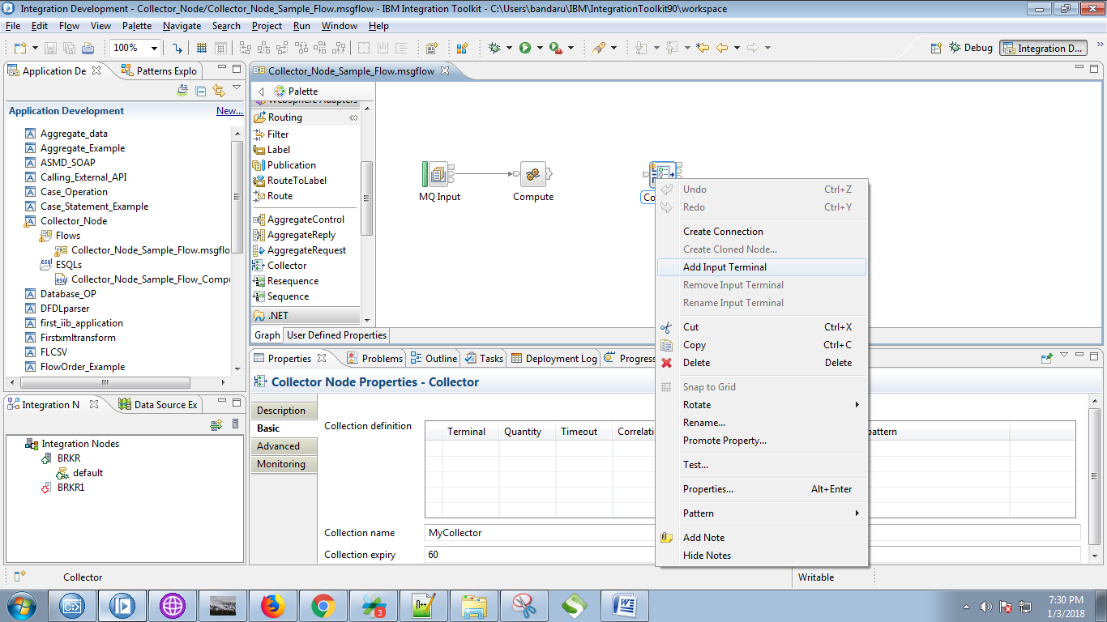

14. Give a name for your input and click on "OK" button.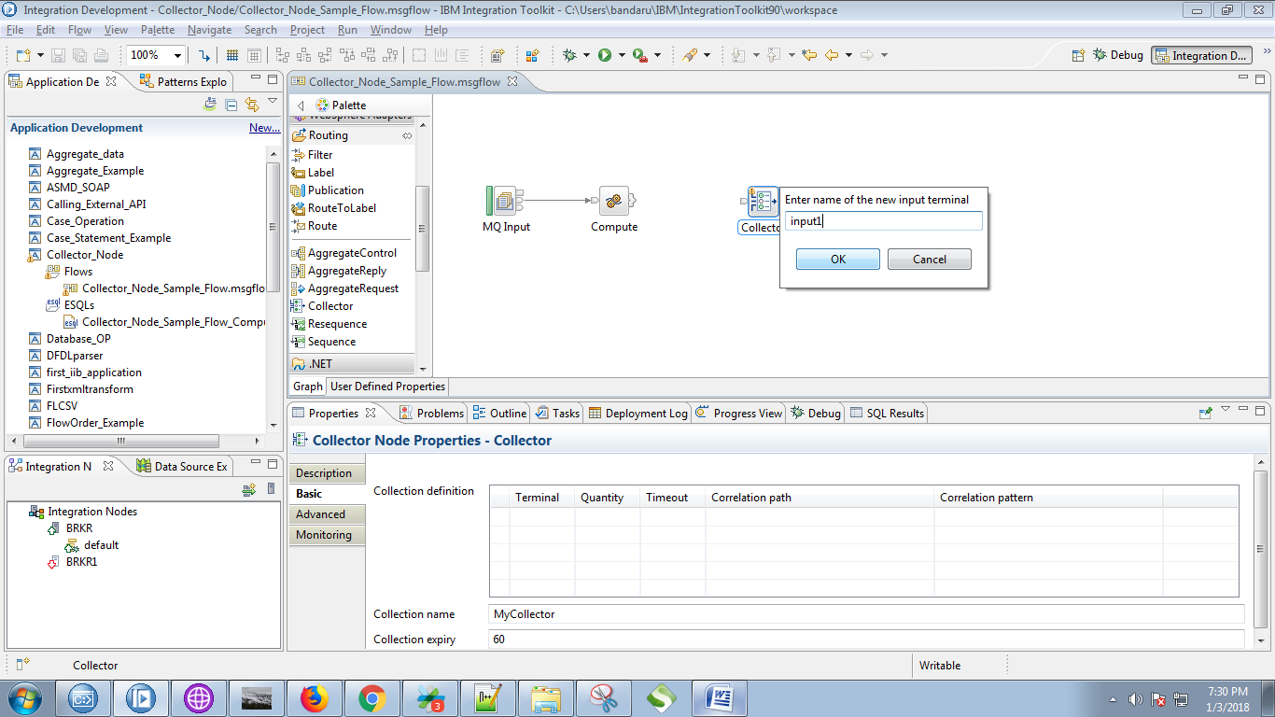

15. You can see your input terminal after it creation as in below fig.

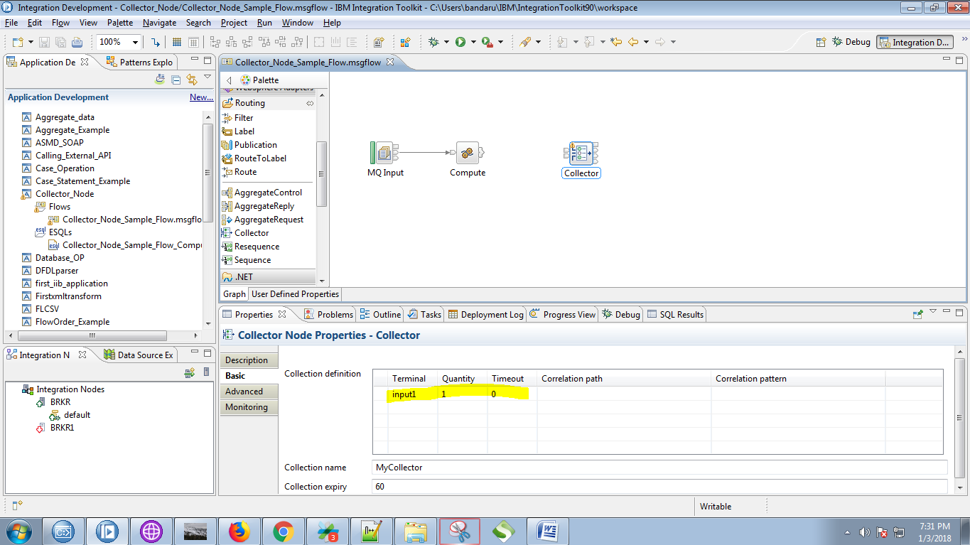

16. Right click on compute node terminals and select "Out" and click on "OK" button.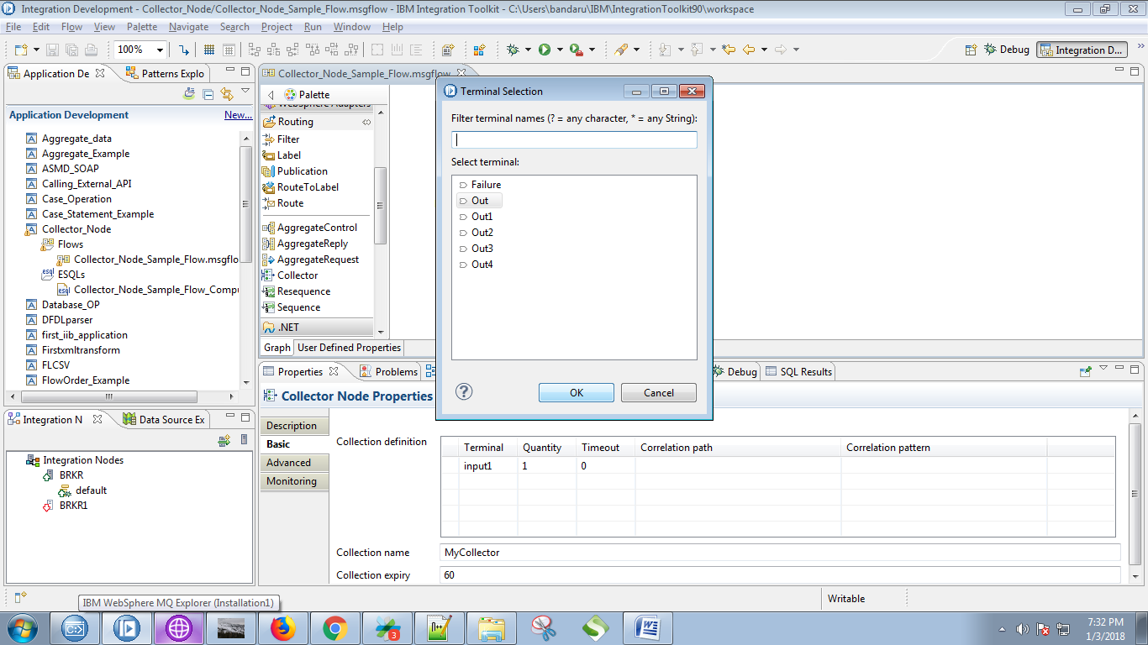

17. Connect the "output" terminal of the compute node with "input" terminal of the collector node.

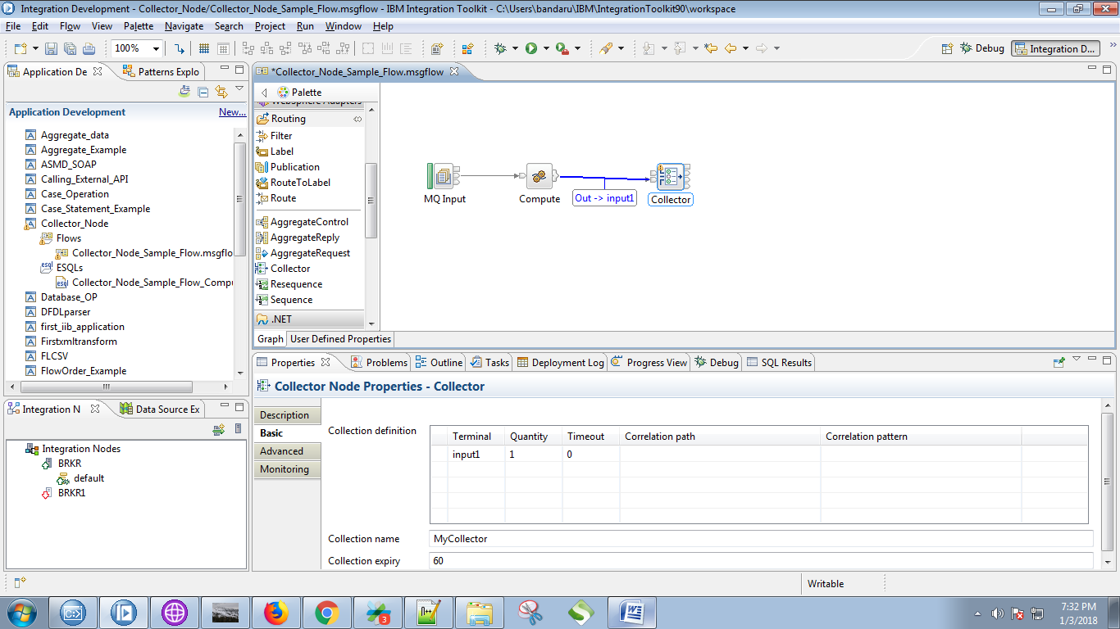

18. Drag the "Compute" node from the "Tranformation" section.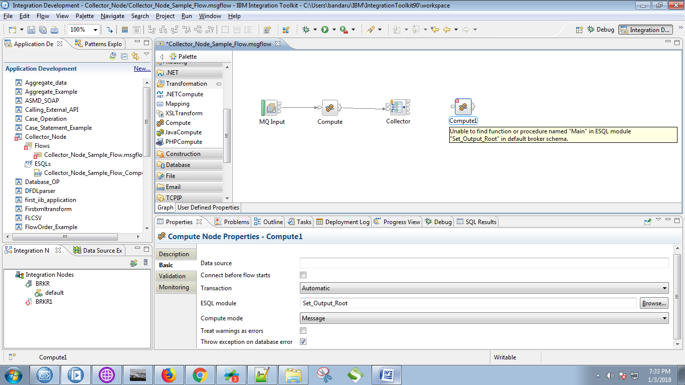

19. Connect the "output" terminal of the collector node with "input" terminal of the compute node.

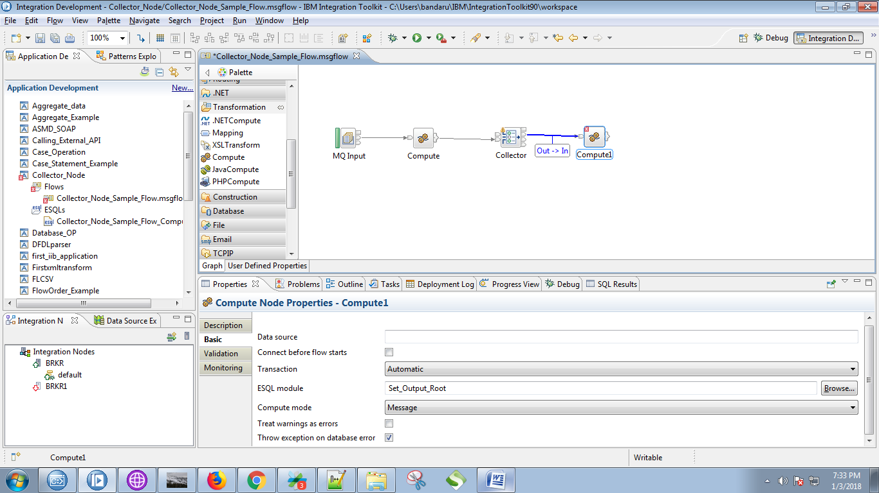

20. Copy the following code in to the compute node.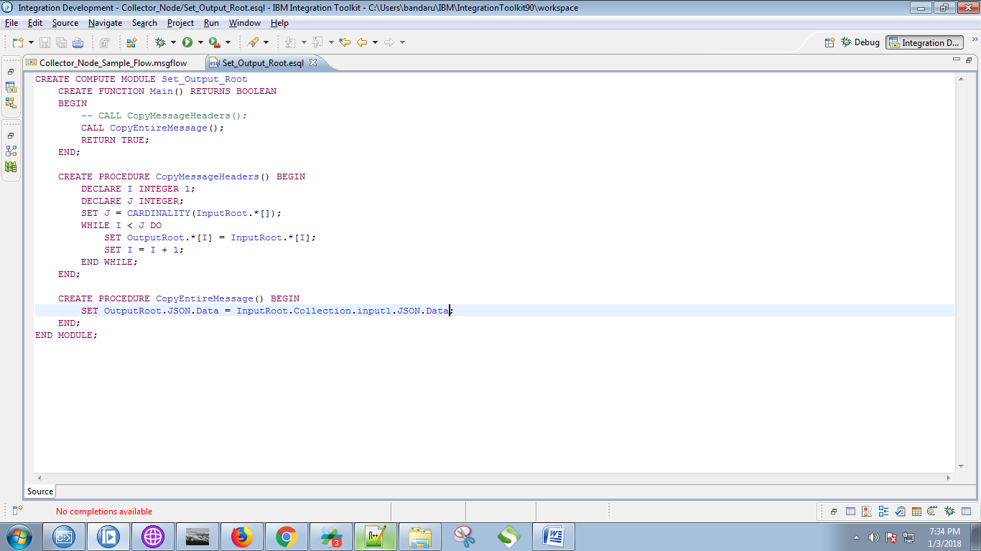

21. Drag the "MQOutput" node and name it properly.

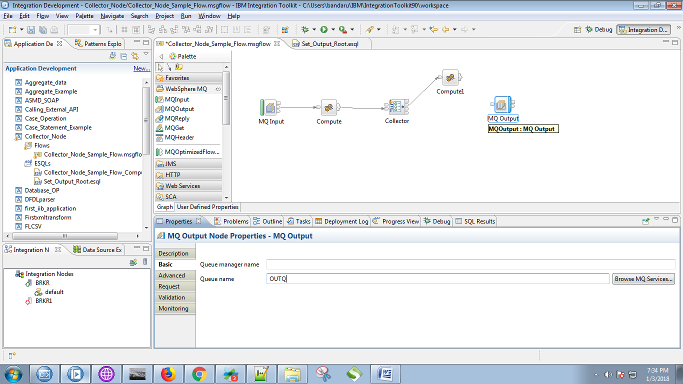

22. Click on output terminals of the compute node and select "Out" and click on "OK" button.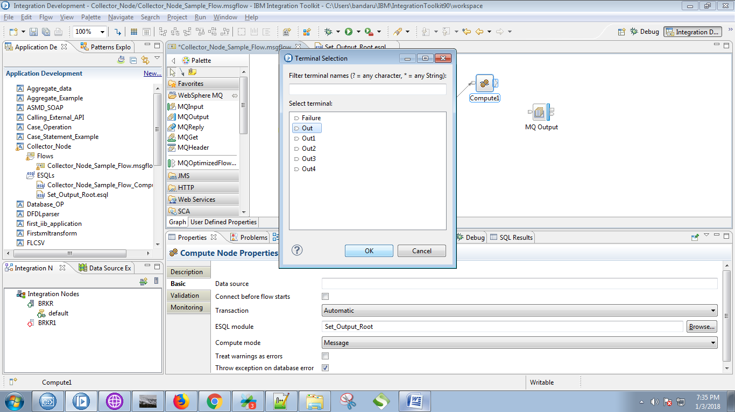

23. Connect the "output" termianl of the compute node with "input" terminal of MQOutput.

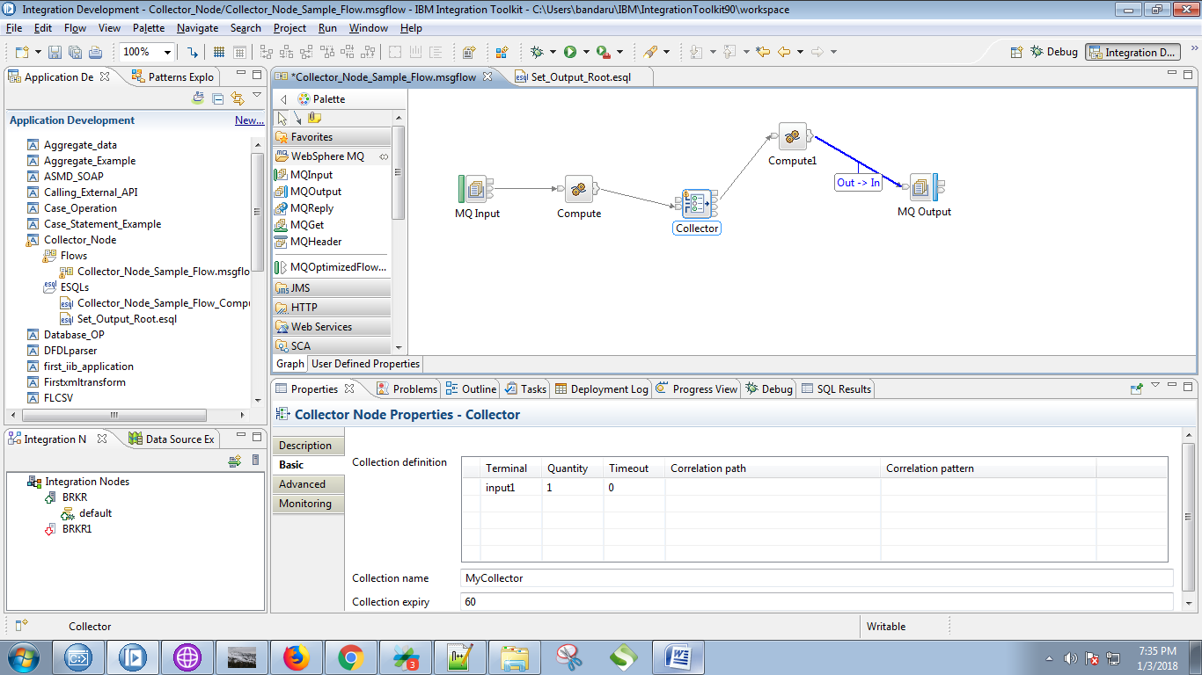

24. Connect the "Catch" terminal of the collector node with "input" terminal of the MQOutput.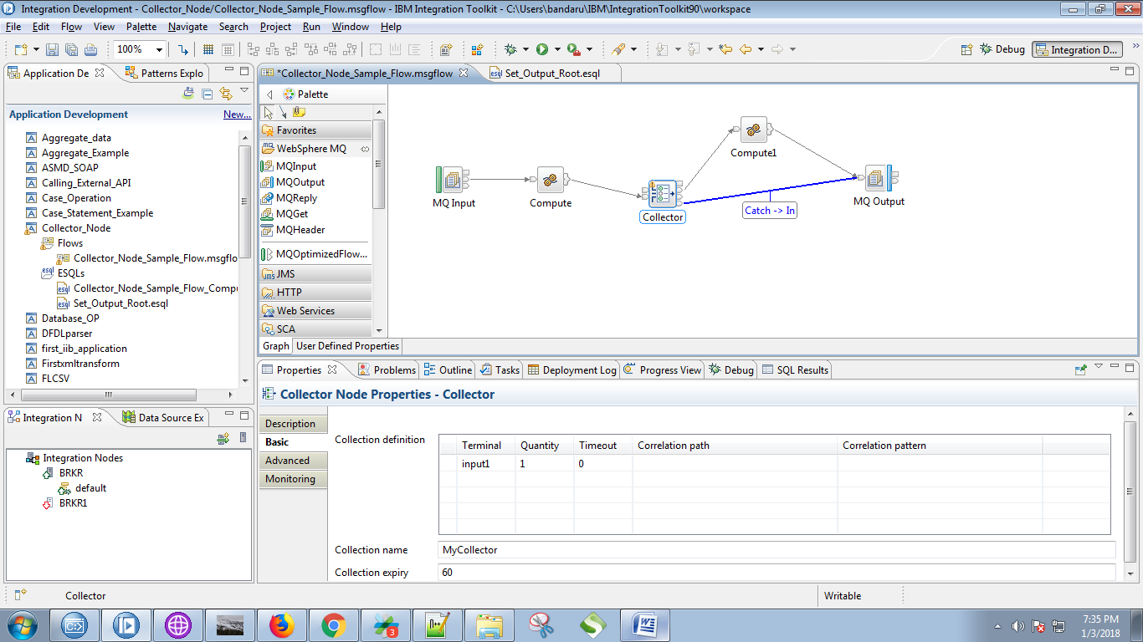

25. Right click on your application and select "Deploy" option.

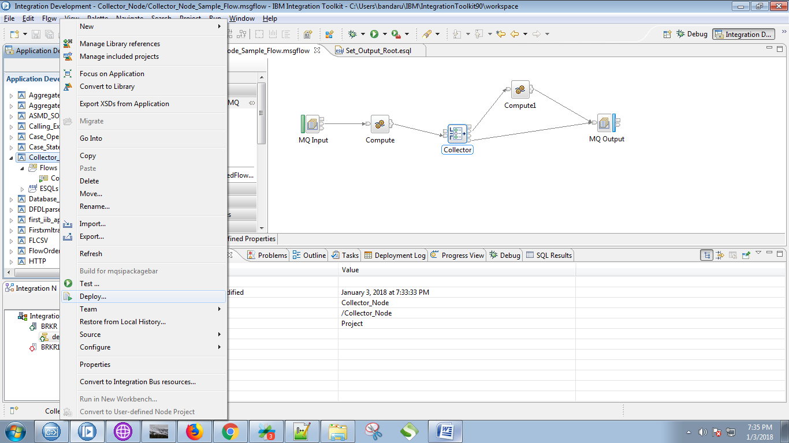

26.Select your broker and execution group and click on "Finish" button.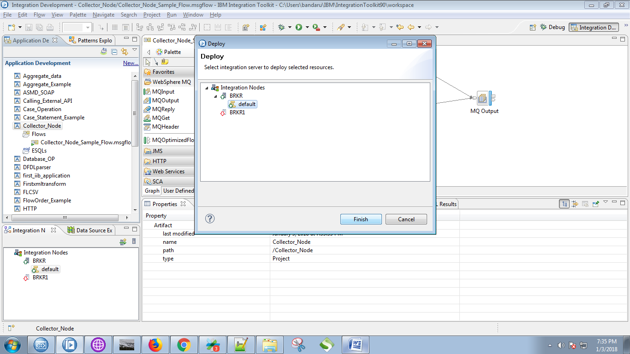

27. Create your respective queues in Websphere MQ Explorer.

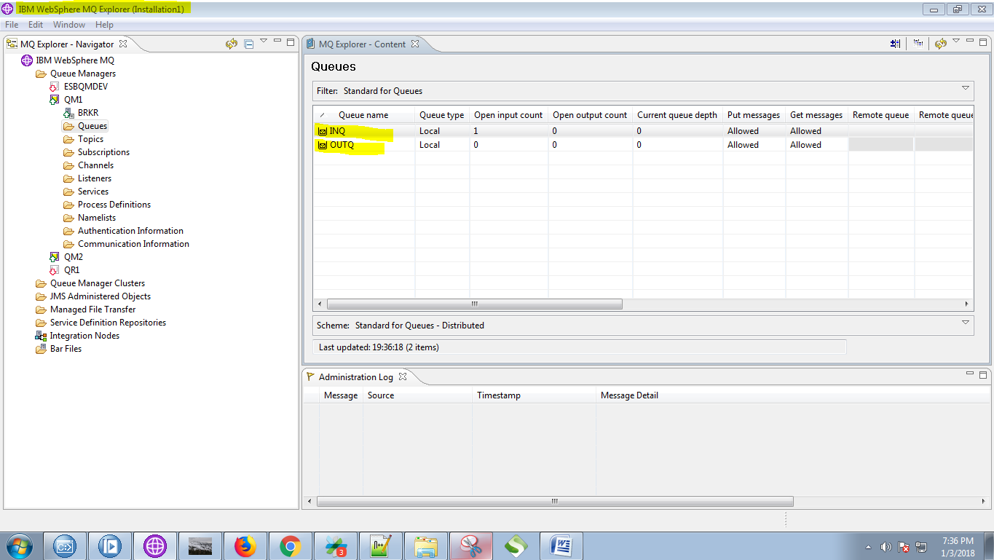

28. Open RFHUtill and select input queue.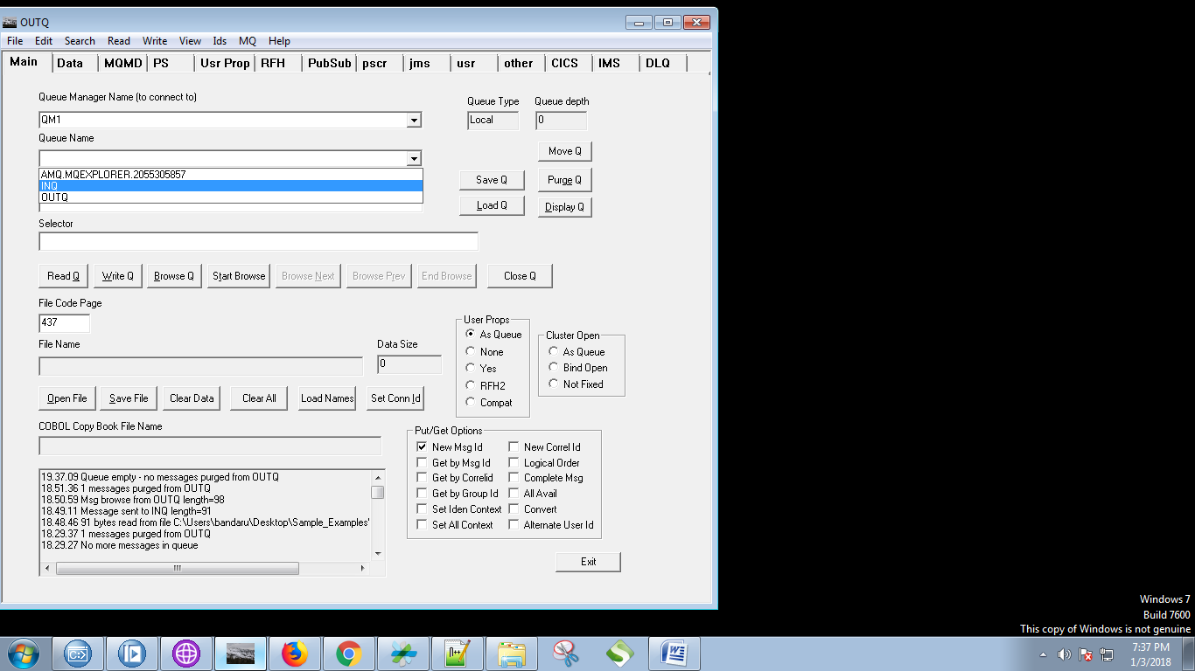

29. Click on "Open File" and choose your input file.

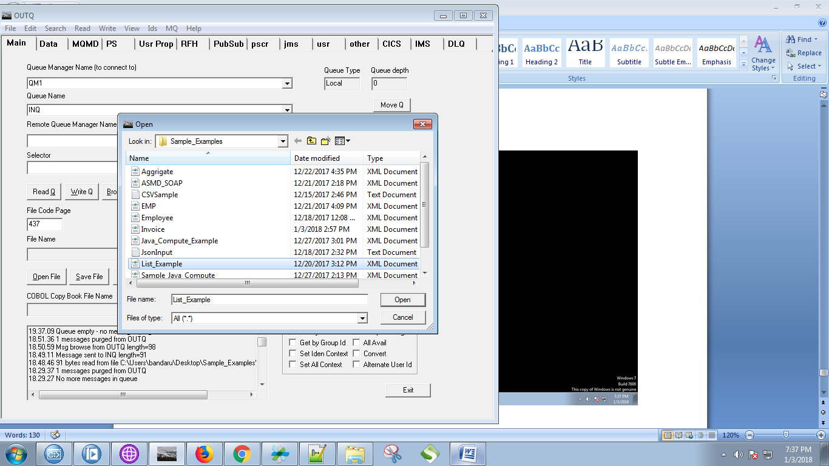

30. For this example i have choosen following data.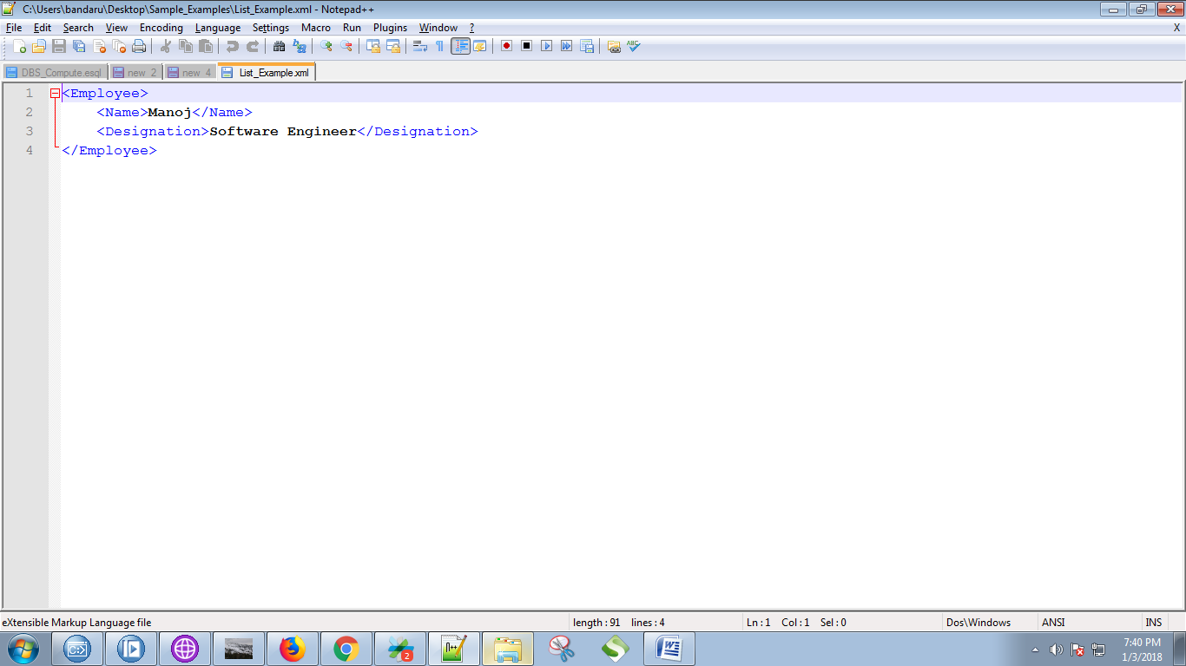

31. Hit "Write Q".

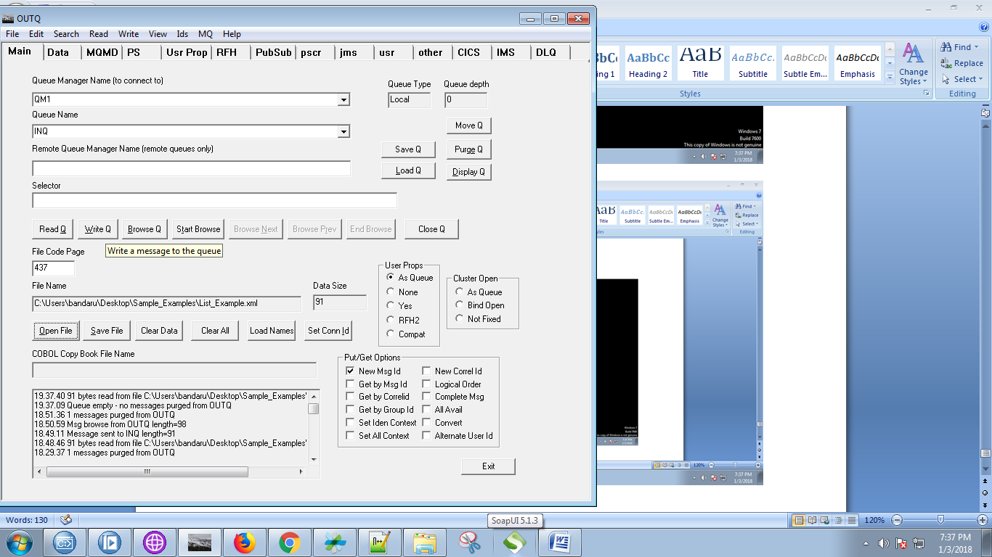

32. Output of the first compute node can be seen i debug.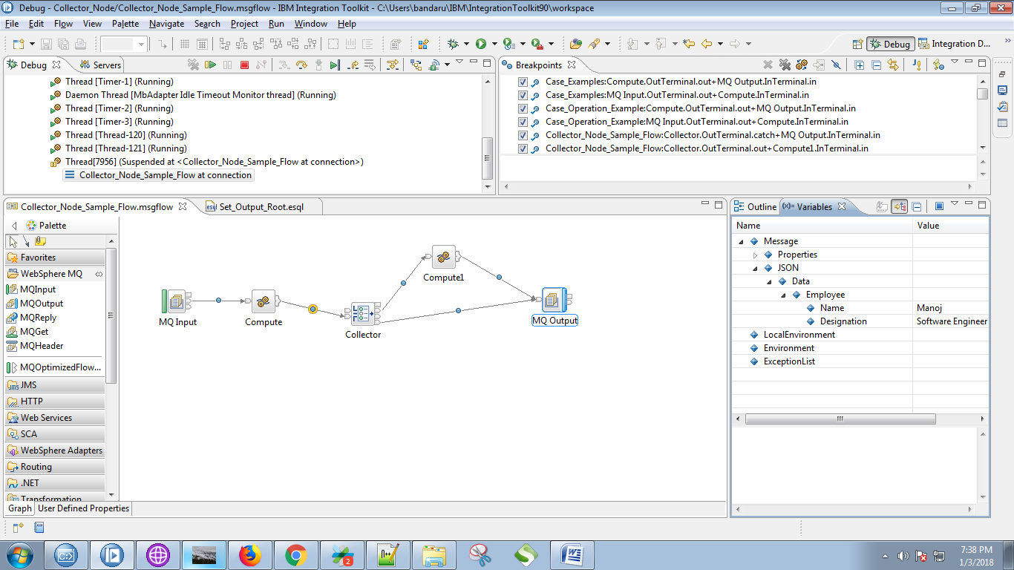

33. Output of the collector node as follows.

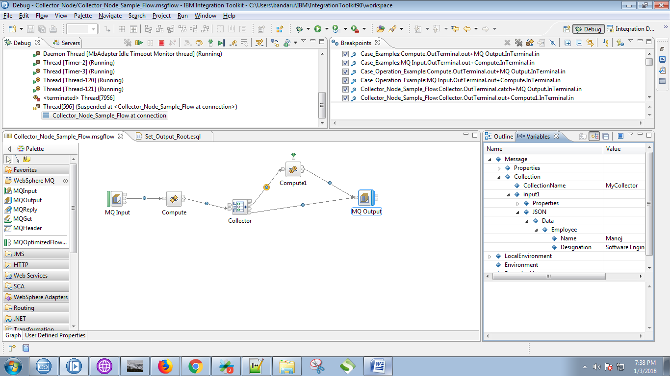

34. Output of the second compute node.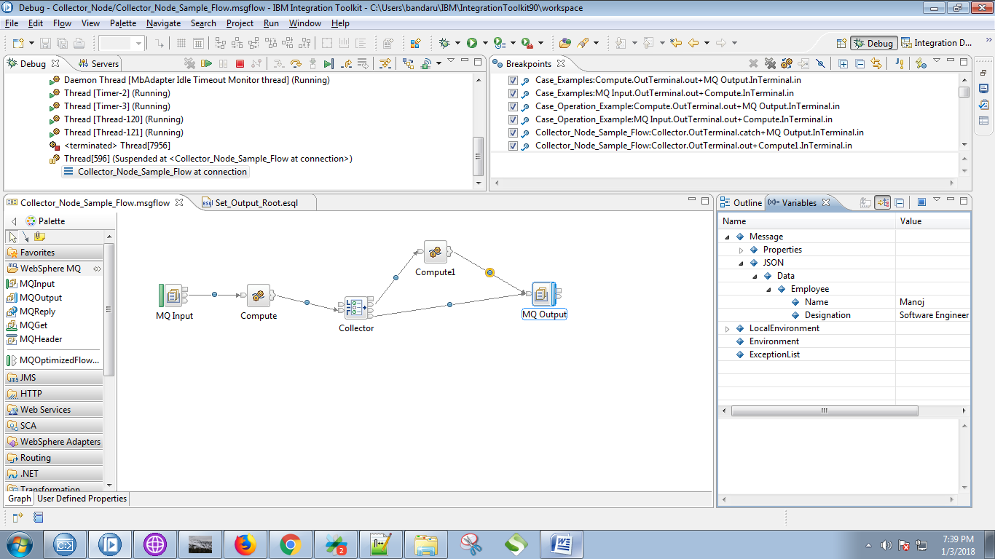

35. After end of your flow, select output queue in RFHUtil and hit "Browse Q".

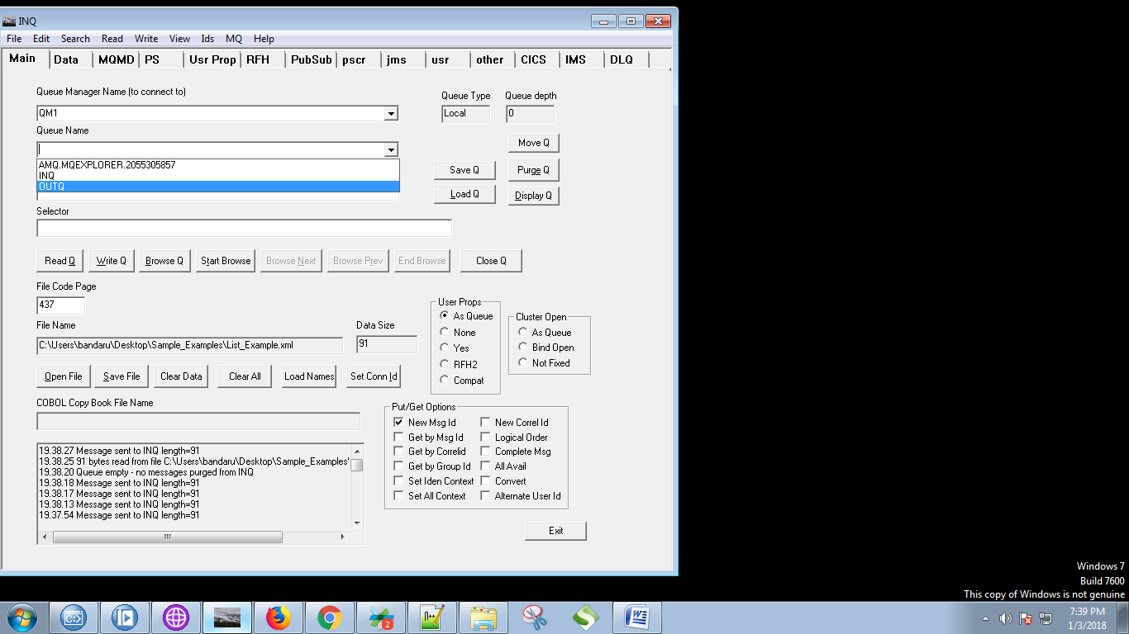

36. Your output can be seen under "Data" tab as following fig.